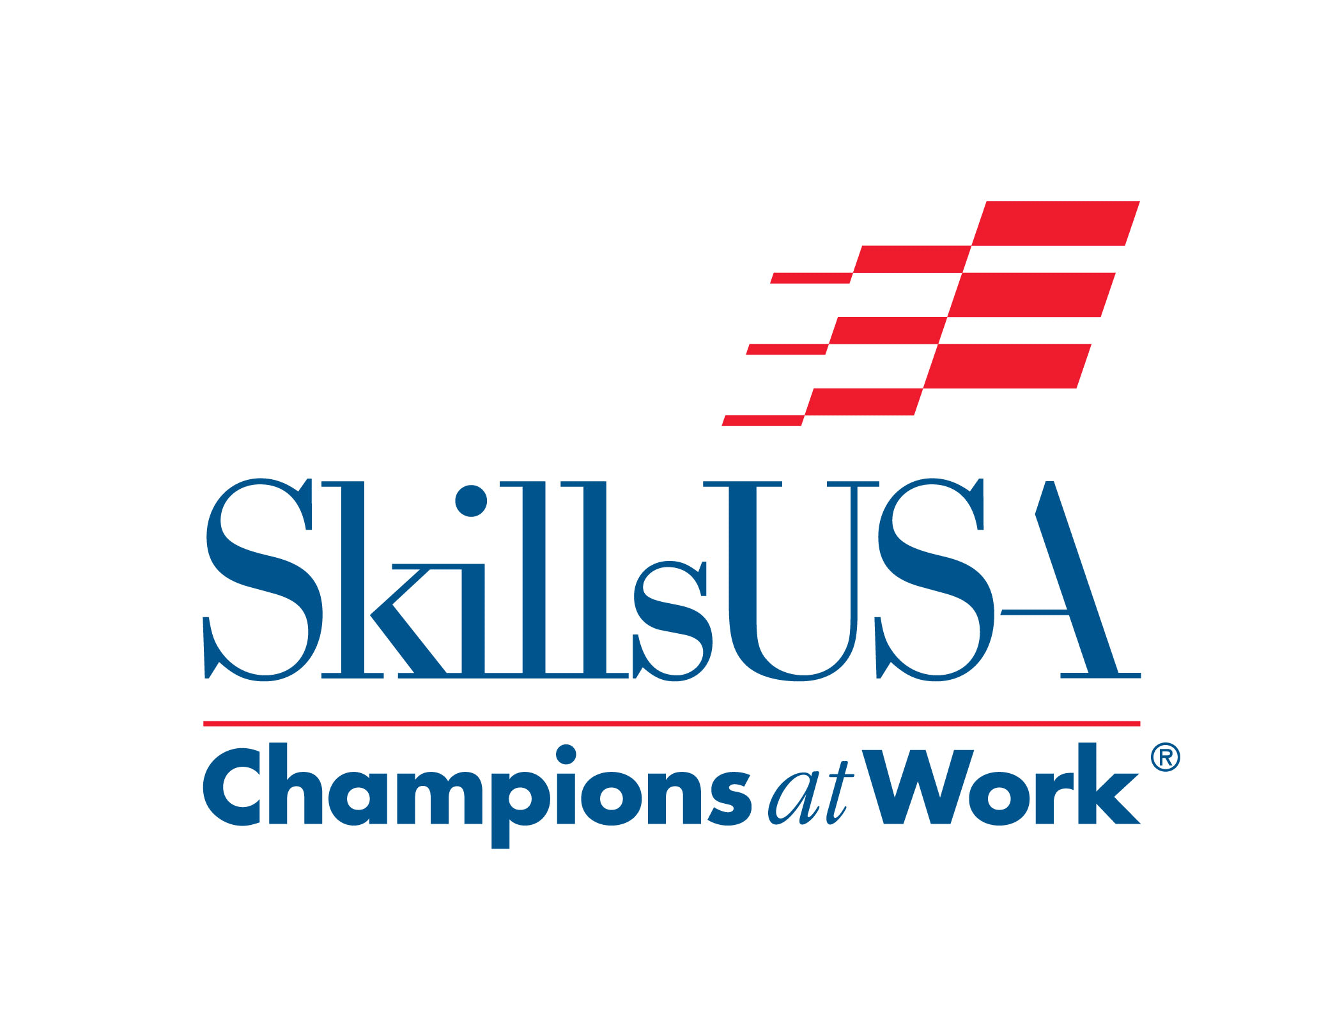
Regional and State Cosmetology Contests
2017
Contestant/Teacher Information

Contestant Information
Uniform Requirements-
For Regional Contests- Official SkillsUSA attire for Cosmetology Contestants, Black Pants and white shirt, or school uniform, i.e. scrubs. NO Denim.
School uniforms should NOT have the school name or contestant name on them. Points will be deducted.
Shoes should be leather black shoes. No heels, flip flops, or open toed shoes. Students must wear socks or hose.
Mannequins Needed-
2 Blonde Mannequins. All students will have the Blonde Mannequins to level the field. Any other mannequins used will have points deducted. Burmax offers a discount for Sam II Blonde mannequins for SkillsUSA competitors. Contact your Burmax representative. Other alternatives that can be used… Marianna Barbara Blonde or Morris Flamingo Susan Blonde Mannequin.
One mannequin will be used for the women’s haircut and style. This can NOT be pre-colored or NOT pre-cut. Points will be deducted if mannequin is precut or precolored. Manniquins should be new from the box.
The second mannequin will be used for the creative updo. This mannequin can be pre-colored and pre-cut if needed.
NO MAKEUP, JEWELRY or SCARVES MAY BE ADDED TO THE MANNEQUINS AT ANY TIME BEFORE OR DURING THE COMPETITION.

Supplies needed-
Competitors must bring their own supplies.
Judges will do a kit check before the start of the contest.
Some items may not be used in the contest.
◊ Sam II Blonde Burmax, Marianna Barbara Blonde or Morris Flamingo Susan Blonde mannequin for women’s cut and style (May NOT be pre-colored, NOT pre-cut)
◊ Second Sam II Burmax, Marianna Barbara Blonde or Morris Flamingo Susan Blonde mannequin for creative updo (May be pre-colored, May be pre-cut)
◊ Mannequin stand or tripod.
◊ Sectioning Clips of Choice
$◊$Combs of Choice-Haircutting, Rattail, Teasing
◊ Detangle comb
◊ Hair Pick
◊ Brushes of Choice- All purpose, Thermal, Boars, Teasing, Vent, Round, Denman
◊ Hair Spray
◊ No more than 3 styling products
◊ Shears
◊ Texturizing/Thinning Shears
◊ Razor w/ blades
◊ Curling Iron and/or Flat Iron
◊ Blow Dryer w/ concentrator attachment
◊ Cape (Full length or comb out cape can be used for mannequin)
◊ Sanex Strips
◊ 4 Cloth Towels
◊ Bobby Pins/Hairpins/Elastic Bands (Optional)
◊ Clippers (Optional)
◊ PRE FILLED Water bottle- Labeled (there is no water available at competition sites)
◊ Disinfectant in Spray Bottle-Labeled-No need for a barbacide jar
◊ Plastic Shoebox with covered container for dirty combs and brushes-Labeled
◊ Small Dustpan and Broom
◊ Small Baggie for disposal of hair
◊ Gloves
◊ Band aids- small first aid kit
◊ Extension cord
◊ Small stand up mirror (Optional)
◊ Pencils for written test
◊ Resume

Any other items must be shown to the judges for approval before the start of the contest.

General Contest Outline

Contestant Orientation
Contestants will meet at the contestant holding area.
Contest facilitator will go over procedures and answer any questions.
Contestants will draw for stations.
Contest Set up
Contestants will set up stations.
Remember to disinfect stations prior to using.
All tools and supplies should be disinfected prior to arrival.
Stations should be set up in a professional manner.
First Women’s Haircut Mannequin should be set up and properly draped.
Judges Kit/Supply Check
Judges will check for all required supplies for points.
Begin Women’s Haircut
Mannequin- Blonde- May NOT be pre-colored and NOT pre-cut.
No makeup or Jewelry pre-applied or at any time during contest.
Contestants are given the haircut technical and will have 5 minutes to preview before
beginning.
When time is called to begin, contestants will have 45 minutes to complete the haircut only-no style.
Haircut may be completed with tool(s) of choice, Shears, razor, texturizers, clippers.
When time is called to stop, contestants are not to touch mannequin until instructed
by the facilitator.
Creative UPDO
Sam II, Barbara or Susan Mannequin- May be Pre-colored and/or Pre-cut.
No makeup or jewelry pre-applied or at any time during the contest.
Theme is “creative”. This theme is open to interpretation for the contestant.
Mannequins cannot be preset using any wet set technique or thermal curls. Mannequin should be dry.
Contestants will have 60 minutes to compete the creative updo.
Thermal tools may be used to create the updo.
No hairpieces, weaving, ornaments, extensions, ribbons, color spray, glitter or crimpers may be used. No ornaments or hairpieces are allowed.
Contestants may NOT apply makeup to the mannequin (no special effects makeup or paint).
No eyelashes will be allowed.
When time is called to stop, contestants are not to touch mannequin until instructed
by the facilitator.
Blow Dry Style- Women’s Haircut
Students will have 30 minutes to complete style on women’s haircut.
Thermal tools may be used.
No hairpieces, weaving, ornaments, extensions, ribbons, color spray, glitter or crimpers may be used.
No ornaments or hairpieces are allowed.
Contestants may NOT apply makeup to the mannequin (no special effects makeup or paint).
No artificial eyelashes will be allowed.
When time is called to stop, contestants are not to touch mannequin until instructed
by the facilitator.
Oral Communication
Competitor will turn in Professional Resume to Judge. Please make sure resume is authentic.
You will be judged on oral communication skills and how you present yourself. You will be asked for a brief explanation of your creative style. You can present inspiration, color placement techniques and style techniques using professional terminology.
Judges may ask questions.
Written Test
50 question test assessing general knowledge of Cosmetology.
Competitors will have 45 minutes to complete.
Competitors should bring their own pencils.
Infection Control Procedures
Competitors should practice the highest levels of infection control during the contest.
Competitors should disinfect stations prior to and at the conclusion of the contests.
Competitors must sweep their own hair with personal broom and dustpan and dispose of in their own baggie.
Use the plastic Shoebox labeled “dirty tools” for your dirty combs and brushes.
Professionalism
Competitors are expected to conduct themselves with a professional, friendly, helpful professional attitude.
All techniques should portray professionalism and confidence.
Cell phones should be off and out of sight for the duration of the contest.
Only communication with judges during the contest.
Mannequins should be displayed level so that judges can score properly.

Other information
There should be no contact between advisors and contestants during the contest.
It is up to the host school to determine if observers can watch the contests, this is determined by space availability.
Contestants will be given restroom breaks at the discretion of the facilitator.
Upon completion of the contest, once judges have completed judging, there will be a
picture opportunity for advisors and spectators.
If you cut yourself during the competition with the shears, you should have your own Band-Aids, etc. However, if it is a severe cut, please call the facilitator or judge.
You must arrive on time to your contest. If you arrive late, you may be allowed to join in but will not be given extra time.
If you have electrical problems, please see a judge or facilitator.
Only contestants, not advisors, can file a grievance.

NOTE:
If a contestant feels that a rule violation occurred during the contest, the contestant may file a grievance. The grievance form may be obtained from the head contest judge and must be returned to same. The head judge must accept the grievance and must make a ruling on the grievance.
If the head judge cannot rectify the grievance to the satisfaction of the contestant, then and only then may the contestant ask that the grievance be presented to the official grievance committee for consideration.
All grievances must start with the head judge of each contest while the contest is in progress. Time missed while making a grievance report to the judge will be given to the contestant to complete his/her contest without penalty.
No grievances will be filed after the contests are concluded.
Final interpretations of all contest rules will be made by the Florida State Director or the Regional Coordinator at the regional contests.

Special Note to Instructors:

The Florida SkillsUSA Cosmetology committee is committed to keeping all of our advisors informed so all of our SkillsUSA competitors can come to competitions prepared. We are currently working on aligning our contests to the National SkillsUSA Championships Technical Standards. You may see a few changes this year. If you have any questions, please do not hesitate to email us!

Kellyann Haudricourt khaudric@pasco.k12.fl.us

Dawn Eudy d.eudy@burmax.com

