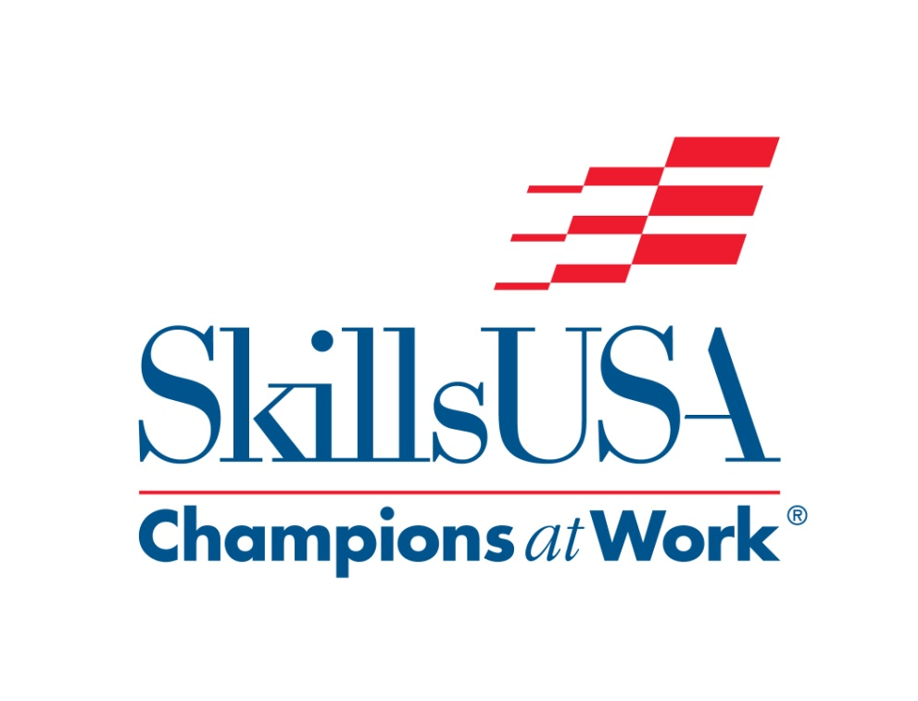

2017
Florida
Regional/State Contest
Esthetics

School Facilitator
Instructor/Contestant
Packet

Materials supplied by host school:

- Work area
- Contestant chair and Facial bed/table
- Models Chair
- Small table (for products)
- Hot water
- Towel cabbie
- All information for judges, the regional coordinator will bring some information

Provided by Regional Coordinator:

- Judges copy of contest, answer sheet for written test (if used), and scoring sheets.

Supplied by the Contestant:

- Model
- Completed consultation cards
- Brow brushes
- Bowls
- Cotton/Esthetic wipes
- Drape/robe and headband for model
- Disposable applicators
- Eyelashes and adhesive (optional can be used at regional, state and national)
- Hand sanitizers and or alcohol wipes
- Paper towels and or baby wipes
- Resume in a page protector (State and National competitions only) Regional if Required
- Scissors
- Sheets (one flat, one fitted)
- Spatulas
- Sponges
- Towels (white cotton)
- Tweezers (optional if needed for eyelash application)
- Products of contestant’s choice for facials, makeup and sanitation
- Fantasy Makeup interpretation/story in a page protector (State and National)

Continued supply list:
- Make-up brushes
- Day and Evening make-up for Regional contest
- Day and Fantasy Makeup for State and National contest
- Blush
- Cape for makeup application
- Concealer/cover-up
- Eyeliner
- Eye shadow
- Foundation
- Highlighter
- Lip liner
- Lipstick
- Mascara
- Powder

Facial Products:
- Cleanser
- Exfoliate/scrub
- Toner
- Mask
- moisturizer

Sanitation supplies:
- First aid kits- Band-Aids
- Disinfectants for the table/bed/counter chairs etc.
- Gloves
- Hand sanitizer
- Neck strips
- Plastic bag for garbage (Large baggie may be used)
- Bag for soiled laundry

All Sanitation, disinfection and set-up must be done by the contestant.

The 2017 Regional and State written exam will be taken from Milady’s Standard Fundamentals Esthetics 11th edition
Chapters:
Life Skills
Your Professional Image
Infection control
Physiology and Histology of the Skin
Hair removal
Skin Disorders
Facials
Facial Makeup

Extra information pertaining to the Fantasy Make-up portion of the Esthetic’s contest at State and National levels of competition:

- The Fantasy make-up portion of the esthetic’s contest 2017 theme will be “Floral or Fauna”.
- A written description of your character and interpretation within the theme is to be limited to one page, typewritten and contained within a plastic sleeve. The description must be submitted at the contestant orientation.
- Props such as hair ornaments, wigs, and jewelry, may be used in the fantasy section but will not be considered in the judging. All items must be placed within the timing of the fantasy portion of the contest, and placement must complete within the time limit.

Additional Supply information:

At the Regional level of competition contestants will be required to bring all their supplies to be used during competition.

State and National Esthetics Contest Committees may supply facial products (example: cleanser, exfoliate, mask, toner, and massage cream) for contestants to use during competition. If the facial products are supplied by the Esthetic Contest Committee, contestants will not need to bring facial products to the contest. When preparing for State and National competitions, look for updates at the Florida State and National Skills USA websites.

During all contests, Regional, State, and National levels, all products and solutions must be properly identified with the manufacturer’s original packaging and original labeling. Product labels cannot be defaced.

Project Information

Skill Performance

An oral communication test will assess contestant verbal presentation skills. The four separate skill performance tests assess skills in massage, basic facial, daytime and nighttime makeup application, (Regional contest) and daytime and fantasy makeup application (State and National contests), at multiple performance stations. Creativity is assessed in the fantasy makeup application, while technique is tested in the performance of massage, basic facial and daytime/nighttime makeup application. An emphasis on safety and sanitation will be used in all segments of the skill performance areas. Observations during each segment and evaluation of the finished product will be considered in the scoring.

Contest Guidelines

1. The contest rules will be reviewed at the scheduled orientation. After the review session, contestants, in their required dress, will take the oral communications and written tests. Contestants will then be escorted to the contest site to receive final instructions. The contestant will turn in his or her résumé and written theme for the fantasy makeup application(State and National) upon check-in at the scheduled orientation.
2. All contestants must keep their working area clean and organized.
3. All contestants must follow sanitation and safety procedures throughout the contest. Floor monitors/judges will assess decontamination procedures and safety practices throughout the contest.
4. All contestants must bring a model for the competition.
5. Contestants will perform a five-minute (regional) three-minute (State/National) oral assessment. This may be a client consultation (contestant are required to bring a completed client card in a protective sleeve to the contest) including skin analysis, suggested facial treatments, fantasy makeup theme or other skill-related tasks. The subject will be determined annually and posted at: www.skillsusa.org/compete/updates.shtml.
6. Time limits for the Regional contest:
45 minutes for the written exam, 45 minutes for the facial portion of the contest: 5minutes consultation/oral exam, 20 minutes for basic facial, 7 minutes for facial massage, 10minutes mask and 3 minutes moisturizer. 60minutes for the makeup portion, (45 minutes for daytime makeup application and 15 minutes for nighttime application regional). 45min daytime 60min fantasy (State). Time is specified during competition. (For example, during the basic facial segment, no work may be completed or started on the facial massage application.) Judges may adjust as long as all competitors are given the same amount of time. Look for updates for State and National time information.
7. Disqualification or penalty points taken can occur for the following, any rule not followed, with no exceptions!
b. Leaving the competition area before completion of task (applies to both contestant and model) without proper escort
c. Unauthorized use of a product that is not allowed or that doesn’t appear in the above listing
d. Any product that appears to have been altered. All products and solutions must be properly identified with the manufacturer’s original packaging and original labeling. Product labels cannot be defaced.
8. Professional attitude and communication is expected throughout the contest

Practical Problem

Each student will be allowed 45 minutes to complete the Facial portion. When time is called the student doing the hands on will stop working and leave the area. The next team will start their procedure and “so on” until all teams have participated.

When all students have completed their “hands on”, while judges are completing their evaluation, each contestant will be guided to the written test area. They are given 45 minutes to complete the written test.

PLEASE NOTE: These time allotments are calculated on a starting time of 8:00 a.m., if your Host Facility has an earlier or later starting time, please adjust according.

8:30 am – 8:45 am Orientation

8:45 am the first team will start the Facial and will be allowed a total of 5 minutes consultation card/ oral exam, 45 minutes to complete the entire facial procedure.
After the facial the contestants will have 60 minutes to apply make-up to their model. Daytime makeup application 45 min. and nighttime makeup application15min (Regional)
Make-up should consist of:
- Blush
- Cover-up/concealer
- Eye liner
- Eye shadow
- Foundation
- Highlighter
- Mascara
- Lip-liner
- Lipstick
- Powder

When time is called, the first team will stop working, the next team will start. This will continue until all teams have competed.

The written test will be given to all competitors when the last team has finished the hands on portion. They will be given 45 minutes to complete this section of the contest.

Set up area:
- Model/Client information card and consultation to be completed before competition starts.
- Client information card should include: skin analysis, skin type, skin condition, health condition, and products to be used and home use recommendations.(5min) (Regional card+oral) (State and National cards will be collected, later a 3 minute oral exam with no cards or props .)
- Assemble supplies and equipment. Judges may decide to have the contestants set up just the supplies for facials first. Once everyone has completed testing, then the judges may instruct contestants to set up the supplies for makeup application contest.

Begin Facial: prior time suggestion (20min)
- Cleanse face and neck twice
- Removal of cleanser
- Exfoliate/scrub
- Removal of scrub
- Toner
- sanitation
Massage: Apply massage cream Demonstrate massage moves. Prior time suggestions (7min)

- Effleurage
- Petrissage
- Tapotement
- Vibration
- Notice contact with the skin
- Sanitation

Mask: prior time suggestions (10min)
- apply mask
- remove mask
- sanitation

Moisturizer: prior time suggestions (3min)
- apply moisturizer
- sanitation

Makeup application: Regional Day time: (45min) then Night time: (15min)
State and National Day time-(45min) then Fantasy: (60min) *watch for updates
- cover-up
- foundation
- blush
- eyeshadow
- eyeliner
- mascara
- lip/liner
- sanitation

