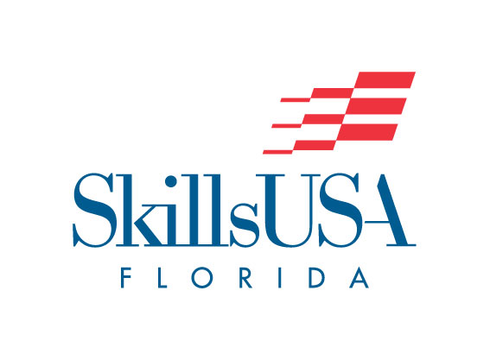

Screen Printing 2019

Supplied by Contestant:

- Earplugs
- Safety glasses
- Apron
- Vinyl gloves
- A one-page resume

