The Total Participation Plan (TPP) is for High Schools and Middle Schools and the pricing includes students, professionals and a required educational resource cost. See the chart below to determine the total cost. A single school or multiple schools in a district or state can be on the same plan. Use the total number of student members between multiple schools to determine the student affiliation. Each school must meet the minimum number of members found in the Total Participation Plan Agreement section.

NOTE: You must have a school administrator username in the membership registration system to create the affiliation agreement online. Contact Patty Duncan at pduncan@skillsusa.org to set-up an admin username.

NO. OF STUDENTS | STUDENT Affiliation |  | EDUCATIONAL RESOURCES |  | PROFESSIONAL  Affiliation | = | TOTAL  COST
01-24 | Not Eligible |  | The formula used for the minimum dollars you must purchase is:  $5.95 x the number of student affiliations.  NOTE: You must pay the retail price of the product you choose to order. Your required purchase may be more if the product you are purchasing costs more than the minimum formula calculated above. |  | The affiliation is inclusive of both your state and the national affiliations. Use the formula below to determine the cost per professional:  State affiliation  PLUS  $20.00 national  For state affiliation cost go to:  http://bit.ly/SkillsUSATPP  Minimum of one professional for every 100 students. |  | Student  Affiliation  +  Educational Resources & applicable shipping  +  Professional Affiliation
25 - 99 | $395
100 - 150 | $640
151 - 250 | $1,312
251 - 350 | $1,750
351 - 500 | $2,185
501 - 650 | $2,750
651 - 750 | $3,045
751 - 1,000 | $3,770
1,001 - 1,250 | $4,425
1,251- 1,650 | $5,340
1,651- 2,000 | $5,900
2,001- 3,500 | $6,500
3,501- 5,000 | $7,550
5,001 - 7,500 | $8,600
7,501 - 10,000 | $9,955
10,001- 12,000 | $11,555

DEADLINES | Action Needed | Description and Instructions
Nov. 15 | Affiliation Incentives | To receive full services from SkillsUSA (including SkillsUSA Champions and professional affiliation incentives) TPP affiliations must be submitted and all students and professionals must be registered online within the SkillsUSA website.
Dec. 01 | Due to your State Association Director.  All First Semester students and professionals registered online.  Order Educational Resources for student use during the school year. | All Total Participation Plan (TPP) affiliations must be submitted for approval online within the SkillsUSA membership website.  All first semester students enrolled in your schools CTE program and all professionals should be registered as members online within the SkillsUSA membership website.  *Order Educational Resources for each student on the plan. Any credit not used by June 1st at the end of the school year will be forfeited.
Dec. 15  State Assoc. Directors | Online affiliations due to National office online. | State Directors should approve and submit all TPP affiliations online within the SkillsUSA membership website.
Jan. 31 | All Second Semester students registered online. | All second semester students enrolled in your schools CTE program and all professionals should be registered as members online within the SkillsUSA website.
Total Participation Plan Agreement

Be sure your school can comply with all the terms and conditions before completing the agreement online.
By submitting an affiliation plan online, you agree to:
- register all eligible students and professionals within the SkillsUSA website. All students must be joined as members if they are enrolled in a career and technical class that SkillsUSA serves and is allowable by state policy.
- register at least 25 students and at least one professional for every 100 students. Your school (s) are responsible for ensuring member names are accurate and not duplicated. Once members are joined in the system drops and cancellations are not permitted. Your school is liable for paying for all registered members including duplicate member names.
- use the TPP educational resource credit to order and implement the required Career Essentials: Experiences to support my program(s). If, at the time I submit my TPP agreement I do not need to order the Experiences I will substitute an order of equivalent value for an approved SkillsUSA Educational Resource or the Career Essentials: Assessments. Once a product type is selected on the TPP agreement, your credit can only be used towards that product type during the year.

- ensure that instructors and administrative staff understand SkillsUSA programs and the proper use of SkillsUSA materials. You agree to provide or arrange for any necessary training for affiliated professionals and will contact the state or national office and arrange for the necessary training.
- implement the SkillsUSA program to all eligible trade, industrial, technical and health sciences students and provide opportunities for eligible students to compete in local, state or national skill and leadership and skills competitions and participate in leadership training and conferences through SkillsUSA. If my school does not register members or participate in SkillsUSA events after the agreement is signed, I understand my school remains liable for payment.
I understand that:
- professionals receive incentives, affiliation mailings and critical contest updates via mail or email, and these may be missed if I fail to register our professionals by the specified deadlines. Students must be registered within the SkillsUSA website to qualify for future competitions and SkillsUSA programming.
- this is an institutional affiliation; therefore, all benefits are provided only to individuals registered as part of this affiliation. The affiliation and all the benefits cease immediately once an individual departs the institution for any reason.
- affiliation pricing includes student, educational resources and professional affiliation. I agree that once I sign and submit the affiliation plan that my school will pay the appropriate student, educational resource and professional affiliation based on the agreement. Members that are joined over the agreed student or professional count are subject to additional billing charges. Billing may take place during the year or after the national March membership deadline.
- PAYMENT IS DUE to the SkillsUSA national office no later than 30 days of the invoice date. SkillsUSA will generate an automated invoice and email to the contact on the agreement once the agreement is approved. The invoice will also be available online and will be mailed each month until paid.

ORDERING PROCESS for the REQUIRED EDUCATIONAL RESOURCES
NOTE: Once you select a product type for your plan and are invoiced as part of your affiliation purchase you cannot change to another product type. Credit is forfeited if orders are not placed by June 1st of the current school year.
Career Essentials: Experiences: By agreeing to the affiliation you agree to purchase and integrate the Career Essentials: Experiences to support your program.
- View product details at http://www.careeressentials.org/experiences and click the Pricing tab, https://www.careeressentials.org/pricing/, for product offerings.
- First time users and schools placing pre-orders click the Total Participation Plan button
- Returning visitors; go directly to the Catalog & Shopping Cart Tile on your dashboard
- Select Purchase Order as your form of payment and enter your TPP invoice number as follows: TPPT123456-E
Pre-Orders
We recommend your school begin implementing the Experiences early in the school year (August or Sept.) to ensure the students have enough time to complete. Follow the pre-order instructions below to place your order.
- Visit https://mycareeressentials.org and click the box for TPP Orders & Pre-orders to begin your order.

If you do not need to order Career Essentials: Experiences, you can substitute an order of equivalent value with our technical Career Essentials: Assessments or with approved SkillsUSA Educational Resources from the SkillsUSA catalog.

Substitution option #1: Career Essentials: Assessments
- View product details at http://www.careeressentials.org/experiences and click the Pricing tab, https://www.careeressentials.org/pricing/, for product offerings.
- First time users and schools placing pre-orders click the Total Participation Plan button
- Returning visitors; go directly to the Catalog & Shopping Cart Tile on your dashboard
- Select Purchase Order as your form of payment and enter your TPP invoice number as follows: TPPT123456-A
  - Not eligible for purchase with TPP credit: Automotive (ASE)

Substitution option #2: SkillsUSA Educational Resources from the SkillsUSA online catalog
- View the SkillsUSA Educational Resources at www.skillsusa.org/store.
  - Your credit may be used to purchase eligible resources found under the bolded links; New Products, Chapter Management and Member Development.
  - Not eligible for purchase with TPP credit: Quiz Bowl Timing Tools, OSHA training course, CareerSafe and all products located on the SkillsUSA Clothing link.
- During the ordering process; in the ordering instructions, freeform area indicate that you are using TPP credit.
- Select Purchase Order as your form of payment and enter your TPP invoice number as follows: TPPT123456-R
Order Support
Career Essentials products: Contact the Career Essentials support desk for technical support and assistance with ordering at 1-844-875-4557 or careeressentials@skillsusa.org
Educational Resources (substitution #2): Contact Roxanne Hodge at 703-737-0618 or email Rhodge@skillsusa.org for technical support and assistance with ordering.

Additional Educational Resource or Career Essentials Suite orders
Educational Resource Orders placed over the TPP invoiced amount are considered a standard product order where a new form of payment is required. All product orders require a secured form of payment at the time of order. Acceptable forms of payment to secure the order is a valid Purchase Order (PO) or credit card payment.

Steps to create an online agreement:
NOTE: You must have a school administrator username in the membership registration system to create the affiliation agreement online. Contact Patty Duncan at pduncan@skillsusa.org to set-up an admin username if you do not already have one.

- Launch to: http://www.skillsusa-register.org

- Create a logon to the registration website if you do not already have one by clicking the button Create Login.

  - In the creation process select the school/organization name that the agreement will be created under.
  - Contact Patty Duncan at pduncan@skillsusa.org to set-up an admin username.

- Next logon using your email address (username) and password you created for your username.
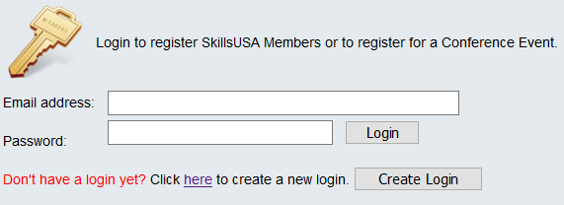

- At the top of the screen click the menu Membership>TPP/Campus Affiliation

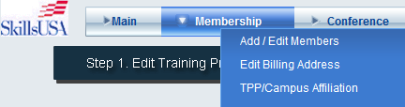

- Click the button Clone Agreement from Last year or Create New Affiliation
  - Clone Agreement copies contact information, billing, all schools on plan and number of members based on actual students and professionals registered previous year. Update each field with changes for this year’s agreement.
  - New Agreement provides a blank agreement in which you will complete with estimated students and professionals on the agreement.
- Click the Edit button in upper left corner to complete or update the contact and billing information.
- In the Schools on Affiliation section click the Edit button and complete the Estimated students and professionals for both first and semester members. i. e columns Est. Student and Est. Professionals.
  - NOTE: Cloned agreements will be pre-filled with last year’s member counts. Update as needed.

- The Edit button will turn to Update when in editing mode. Click Update once completed.
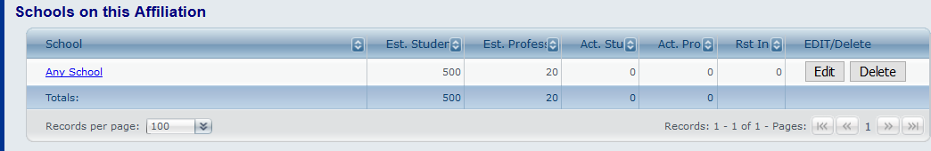

- If multiple schools are on the agreement; at the bottom of the screen, select the school(s) from the drop-down menu and click the button Add School. Complete the step above to add the estimated number of members.
- Click button Review Fees and input your required Educational Resources selection. NOTE: Once you are invoiced you will not be able to change your Educational Resource selection.
Example of screen:
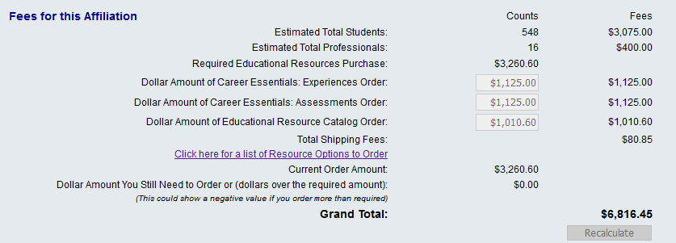
- Click the button 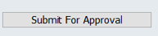 to complete the agreement.
- Once you complete the agreement you will not be able to make changes. The SkillsUSA State Director will approve and accept the affiliation agreement online. You will receive notification via email when the State Director has approved. Once you receive the notification your school will be able to submit members.
- The State Director will submit the agreement for final approval to the national office. Once approved you will be emailed an invoice for the affiliation agreement. Please forward to your accounting department. Payment is due 30 days from invoice date.
  - Note: invoices are accessible online in the affiliation detail screen of your agreement and in the add/edit screen of the registration website.
- To revisit the site with the agreement details and invoice return to the registration website> Membership>TPP/Campus Affiliation.

Questions on the Affiliation plan? Contact Patty Duncan at pduncan@skillsusa.org

